The Lord’s Day

October 1, 2023

World Communion Day

Welcome, today we join with Christians around the world to remember and to celebrate all that Christ did as He gave his life for us. We hope that you will feel Christ's love for you in the breaking of the bread, the passing of the cup and in the midst of our fellowship.

10:00 Worship Celebration

We Enter God’s House To Worship
Prelude

Welcome

Preparation for Worship “Death was Arrested”

Spoken Call To Worship Mary Briley

Leader: In the congregation, let us bless the Holy One.

Congregation: With songs of thanksgiving, we retell God’s wondrous deeds.

Leader: From troubles times and difficult walks,

Congregation: we come to the arms of Christ

Leader: Proclaim God’s name to all the world!

Congregation: In the midst of the congregation, we praise God’s holy name.

Leader: From separate journeys and diverse experiences,

Congregation: we gather to worship as one.

Leader: As brothers and sisters in Christ

Congregation: we come to God, who welcomes us here.

Choral Call To Worship “I Sing Blessings”

Invocation Nathan Pipkin

Children’s Time

Praise Hymn “At The Cross” # 166

Scripture Reading Psalm 78:1-4; 12-16 Peggy McCarter
Time Of Prayer

Special Music Alpha Y Omega Praise Team

Hearing from God’s Word
Scripture Isaiah 43:25
Sermon “Blotting out Our Sins” Pastor

Preparation for partaking the Lord’s Supper

Hymn of Response “Let Us Break Bread Together” # 391
Prayer of Confession
Uncovering the Lord’s Table

Partaking of the Lord’s Supper

Opportunities

Offertory
Scripture Matthew 10:8
Prayer

Benediction Terry Manning

Postlude

We Leave God’s House to Serve.

VIP This Week – Tony and Pam Evans
VIP Last Week – Wayne & Mary Briley

This week’s Adult Sunday School Lesson Scripture – Romans 2:12-24, 28-29
Next week’s Adult Sunday School Lesson Scripture – Romans 7:1-12

Usher Team this week – A
Usher Team next week – B
Deacon of the month – Lon Pierce

Est. avg needed to meet budget - $ 5,775.00
Last week’s general offering - $ 3,550.00

Office Hours:
Monday –Thursday
9:00 A.M. - 1:00 P.M.
Web Page: www.elmgrovechurch.us
Email: elmgrovefw@gmail.com

Opportunities
TODAY:
Choir Practice at 8:00. Sunday School at 9:00. Morning Worship at 10:00.

TUESDAY:
Men’s Bible Study at 6:30.

WEDNESDAY:
Ultimate Wednesday after school. Supper at 5:30 (chicken tenders). Mid-week service, kids and youth meetings at 6:30.

SATURDAY – PREPARATION FOR HOMECOMING:
We will be getting ready for Homecoming beginning at 9:00.

NEXT SUNDAY - HOMECOMEING:
Choir Practice at 8:00. Sunday School at 9:00. Morning Worship at 10:00. We will be enjoying lunch together afterwards in the Family Life Center. Everyone who will is asked to bring enough food for your family and some to share.

TRIP TO RUDY THEATRE:
On November 28^{th,} we will be going to the Rudy Theatre in Selma, NC to see a Christmas show, which begins at 12:45. The bus will leave at 10:00, and we will stop for a quick lunch on the way. The cost of the tickets are $31.00. Please call the church office or see Mr. Frankie for tickets or more information. Tickets need to be purchased by October 15th.

FALL FESTIVAL:
Don’t forget to mark your calendar for October 28th. We need everyone to help that day if possible.

OCTOBER MEN’S BIBLE STUDY:
Starting Tuesday, October 3rd, we will have a four-week men’s Bible Study on the Names of God. The study will begin at 6:30 and will be held in the Conference room in the office. All men are invited to attend.
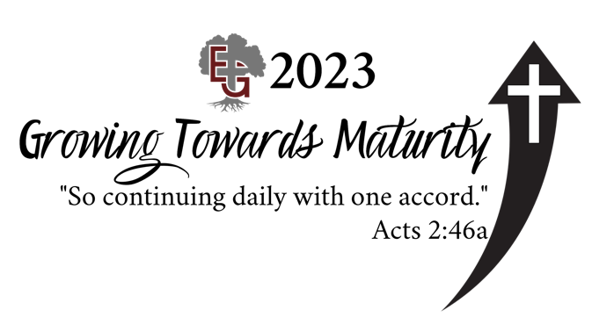

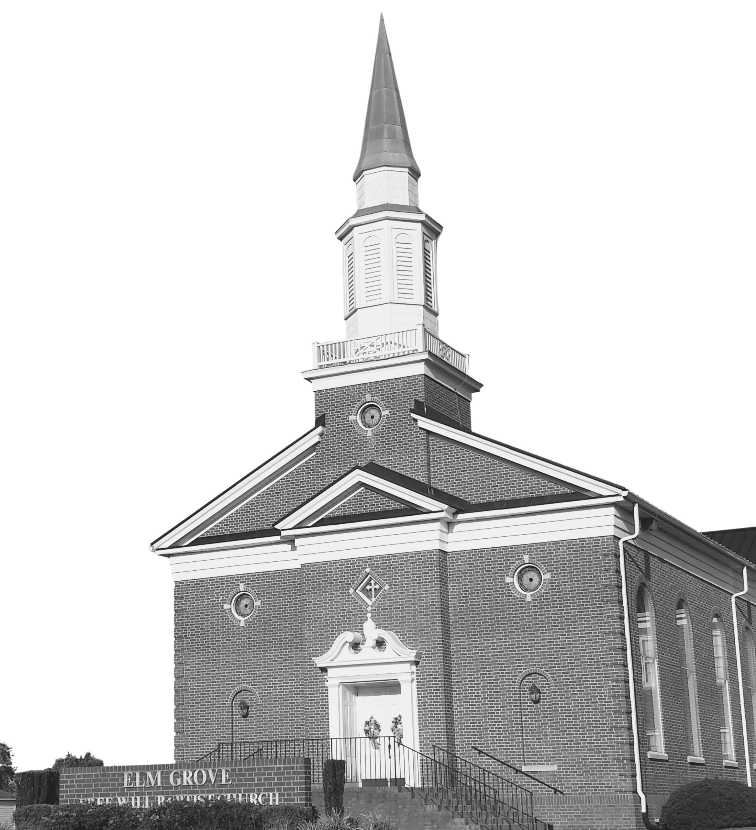

Elm Grove Free Will Baptist Church
5403 Weyerhaeuser Road
Ayden NC 28513
252-746-3534

